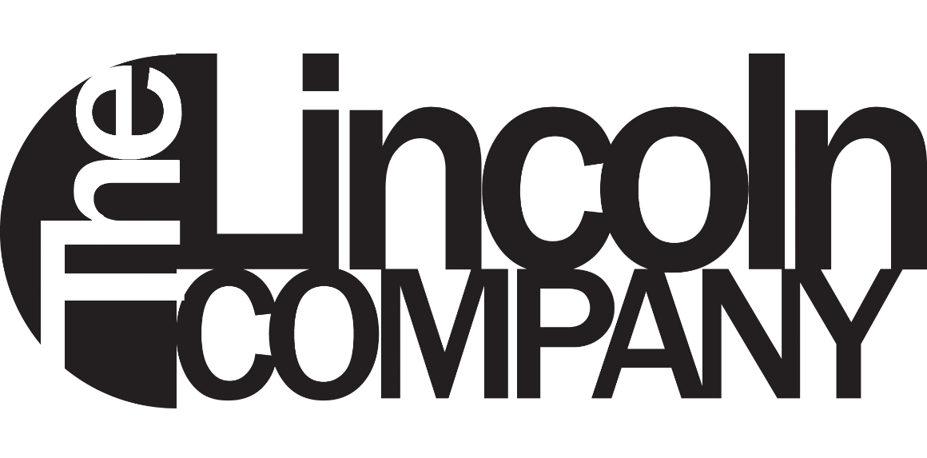

Development Strand

How can we help?

Please complete and return to thelincolncompany@lincoln.ac.uk
Title your email TLC DEVELOPMENT STRAND

Got an idea? Want to scratch that itch, get support and see it develop?

Why yes – of course you do!

We’re always on the look-out for future Lincoln Company Projects. If you have a piece in development and want some support or advice, or perhaps just have an early idea you’d like to try out with some performers, then please complete the form below so we can understand more about your project

There is currently no deadline - we are accepting proposals on a rolling basis and we'll endeavour to discuss them at our next meeting. While we can't work on everything, we promise to consider every proposal.

We are interested in:

- Bold thinking, creativity, playfulness
- Work at ideas stage or very early development
- Those who are open to experimenting, testing and developing their ideas, with the company, for future audiences
- Hearing from current students from ALL programmes, at ALL levels across the school
- Hearing from LSFPA alumni who have graduated within the last 2 years

Your proposal will be considered by the company members at a general meeting, and should the company want to take your idea further, we’ll work with you to determine a plan of action. There is no guarantee that the piece will eventually form part of The Lincoln Company’s repertoire.
Your Name, Email Address and Role in the Proposed Project:
Please list all who are currently involved and indicate the main contact/lead

LSFPA Course and Level of Study, or Year of Graduation:

Working Title of the Proposed Project:

What is your idea or proposed project? (250 words max):

What stage of development is the idea at?
Please briefly describe any work done so far and what development you think the idea requires. You should include the next steps you’d like to take – be honest and realistic.

What resources might you require to develop the idea?
You might not be able to answer everything below but you should consider the following:

How many performers/participants might be involved?
How many others are involved and what do they do?
What equipment/props/set might you need?
What tech support might you need?
Anything else?

Why do you think this might be a good project for The Lincoln Company to work on? (250 words max)?
You should think about your personal reasons for working on this project, but also why it might be good for the company:

Artist or Company Biography (optional – 250 words max):
If you are a solo artist, or are applying on behalf of a company then please tell us a bit about who you are, your work to date, and your artistic aims. Feel free to provide links to a webpage or video/images of your work:

Reference:
Please provide the name of a member of staff who would be happy to support your application – ask their permission first!

